

**PSG COLLEGE OF TECHNOLOGY**

**COMPUTER APPLICATIONS ASSOCIATION**

**COMPUTATIONAL SCIENCES ASSOCIATION**

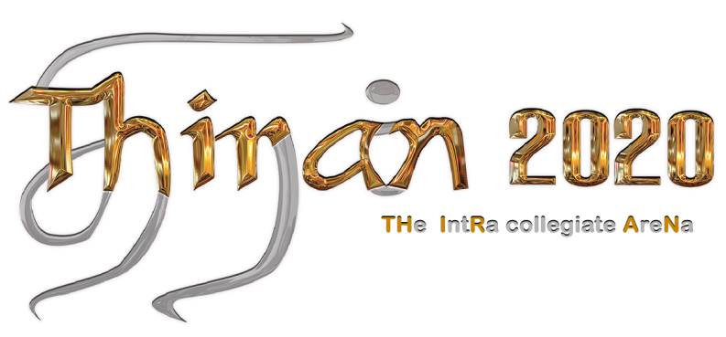Prize Awardees

|  |  |  |  |  |
| --- | --- | --- | --- | --- |
| 1 | **Alg-O-Code** | Winner | Mano Vikram | B.Sc CSD |
| RangaNayaki | B.Sc CSD |
| Runner | KarthikAravind | BE CSE |
| Preethi S V | BE CSE |
| 2 | **Cyber Nerd** | Winner | Balasarath | BE CSE |
| Runner | Sivagurunathan | ME Biometric &Cybersecurity |
| 3 | **Invenirer** | Winner | Santhosh R  Nishok S | B.Sc CSD |
| Runner | KarthikAravind T | BE CSE |
| PreethiS V | BE CSE |
| 4 | **Inquizitives** | Winner | AdwinSanjo J | BE CSE |
| Mani Sankar T | BE CSE |
| Runner | SiddharthIyer | BE MECH |
| Sivadharshan S | BE MECH |
| 5 | **Math Pirates** | Winner | Tharun G | BE ECE |
| Viboosithasra S | BE ECE |
| Runner | Mohan Dass V | BE MECH |
| Vijay B | BE MECH |
| 6 | **Net Hunt** | Winner | Preethi S V | BE CSE |
| 7 | **Last Stand** | Winners | 1.Gokul (FIFA)  1.Mohan (BLUR)  1.Kavin (SIX SIEGE)  2.Varun (SIX SIEGE)  3.Siddesh (SIX SIEGE)  4.Jason (SIX SIEGE) | BE ECE  Instrumentation  IAS  IAS  IAS  IAS |
| Runner | Herithresh (FIFA) | BE MECH |
| 8 | **Techiadz** | Winner | 1.Santhosh R 2.Alamu K 3.Nishok S 4.Sanjay Prakash B 5.Ajith Kumar V | B.Sc CSD |
| Runner | 1.Balasarath BS 2.Sri Nagul G 3.Rubika M 4.Sneha S | BE CSE |
| 9 | **Thiran Tiara** | Winner | TBA | TBA |